1. Install zabbix server and agent2 from its offical site: <https://www.zabbix.com/download>

Note: Before installing zabbix, you need to install postgresql or mysql by yourself (which ever you are choosing while installing server). Also be careful to specify agent2 instead of agent in commands of installation.

1. After installing zabbix server, you need to start zabbix-server service and then search: <http://host/zabbix> to setup zabbix page
2. After setting up zabbix page, install only zabbix-agent2 on the machines on whom you want to monitor services. After installing zabbix-agent2 on machines, go to its conf file at /etc/zabbix/zabbix_agent2.conf file and there edit the (Server=127.0.0.1) & (ServerActive=127.0.0.1) and here give ip address of machine on whom you installed zabbix server.
3. Now restart the agent service and then add host as below

( Note: a. Create Host

b. Create Trigger

c. Create User

d. Create Media Type

e. Create User and add media type there.

f. Create Action )

1. Data Collection --> Hosts --> Create Host

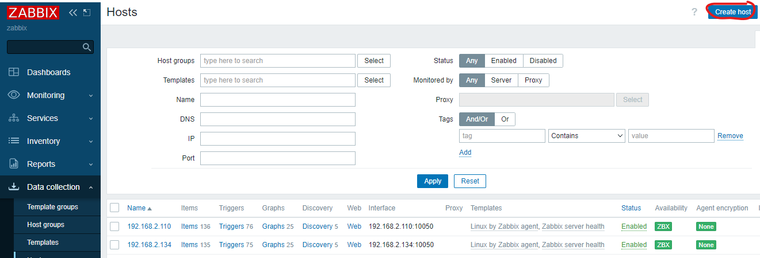

To add a host:

Give a host name --> Add templates as ( Linux server by agent2 ) ( Zabbix server health ) ( MongoDB by agent2 ) (Postgres by agent2) --> Select a Host group --> Click on ADD interface --> select agent --> Give ip address of machine on which you installed agent2 to monitor services. Now click on Macros --> Inherited Macros --> Here you can edit limits already set for different types of built in triggers like cpu utilization, memory utilization, etc. Here you need to add user and password of user for monitoring Postgres and Mongodb by creating a user for both of them with admin priviliges. After creating user for both databases, add their username and password in macros.

For MongoDB, use this command to create user:

db.createUser(

{

user: "zabbix",

pwd: "zabbix",

roles: [{role: "userAdminAnyDatabase", db: "admin"}]

}

)

Now click on ADD to add Host.

Now after creating host, wait till the box named ZBX turns green. If it turns red, then their might be an error of ports if your servers are on AWS or Azure. Hence, you need to open ports ( 10050, 10051 ). Troubleshoot if it still doesnot turns green. You might have made mistake in adding (Server= & ServerActive= ) parameters in conf file of agent on differnet machines.

1. Go to Administration --> Macros --> Add macro --> {$ZABBIX.URL} --> Value: <http://ipofzabbixserver/zabbix>

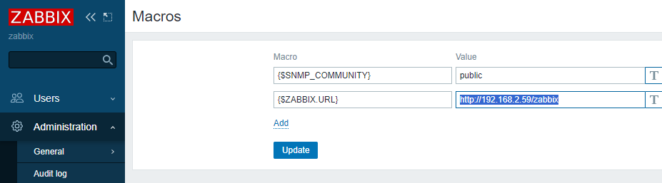

1. Now create a User from:

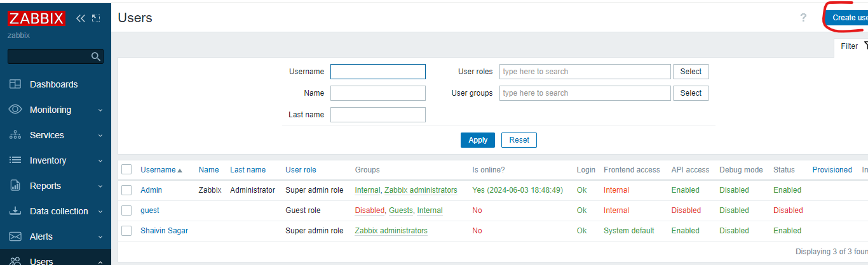

Here click on create user --> Give username --> Add user in a group --> Give password which should have diffetent words then username --> Click on permission --> Give the user Super Admin Privilieges

Now we will be creating Items, Triggers, Media types and Actions for different services:

1. For **yhserver service,** go to DataCollection --> Hosts --> Click on Items from your hostname --> Create Item -->

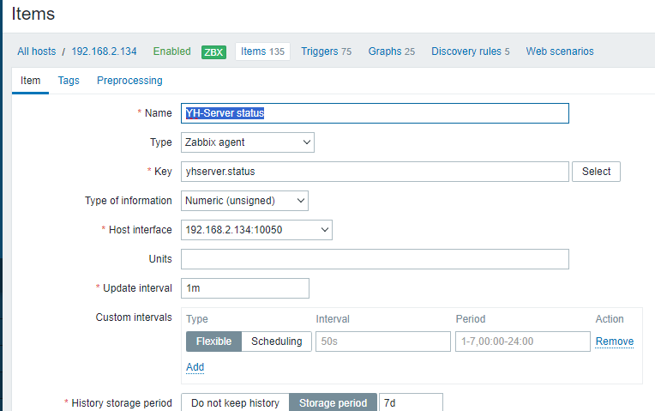After creating the item, go to cmd of your Host machine. Now from it go to agent2 conf file. There you need to add a user parameter as below to monitor yhserver service.

UserParameter=yhserver.status,systemctl is-active --quiet yhserver; echo $?

Now (systemctl is-active --quiet yhserver; echo $?) will give output = 0 if the service is active and output = 3 if the service is inactive.

Yhserver.status is the key which is used while creating the item above.

Now go to DataCollection --> Hosts --> Click on Items from your hostname --> Click on Trigger --> create trigger --> edit as below image. You can type the same expression as below, or click on add expression --> Select your item that you created above, use last function and result = 3

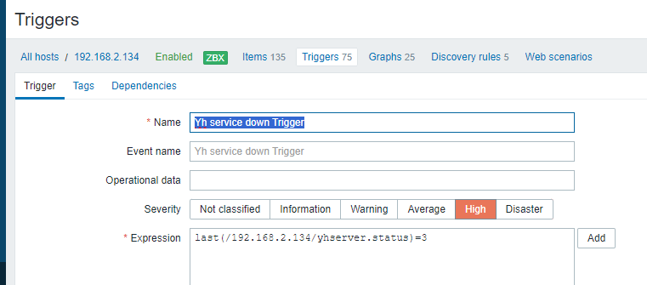

After creating the trigger, now go to Alerts --> Media Types --> Go to MS Teams --> Click on Disabled to enable the media type --> Edit the media type --> alert_subject = YellowHammer service is down --> host_ip = ipaddressofhost --> host_name = nameofmachine --> teams_endpoint = yourwebhook link of msteams channel --> Tick enabled --> Add

After creating Media type, you need to specify that Media type in the user you created earlier. Go to that user --> Click on media type --> select your newly created media type --> update user.

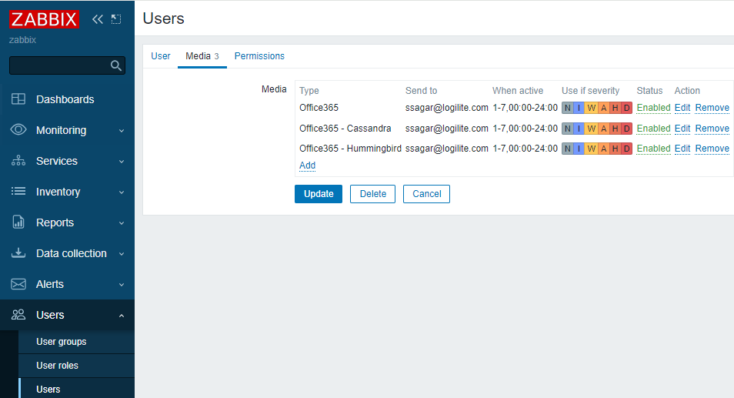

Now after editing user, create action --> Alerts --> Trigger Action --> Click on Create Action

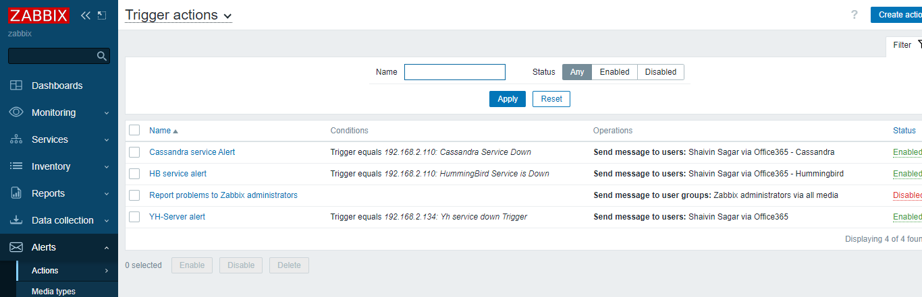

Give name to your action --> Click on add condition --> type = trigger --> then select trigger of yellowhammer you created above --> click on add --> click on operations --> click on Add for operations --> click on send user --> select your user --> click on send only to --> Choose your media type --> click on add --> click on add action.

Now once your yellowhammer service goes down, you will get message in your MS Teams channel.

If you want to use **Office 365** for sending emails for alerts instead of MS Teams,   
Go to Media Types --> Disable MS Teams if created before --> Click on Office 365 --> Edit as below:

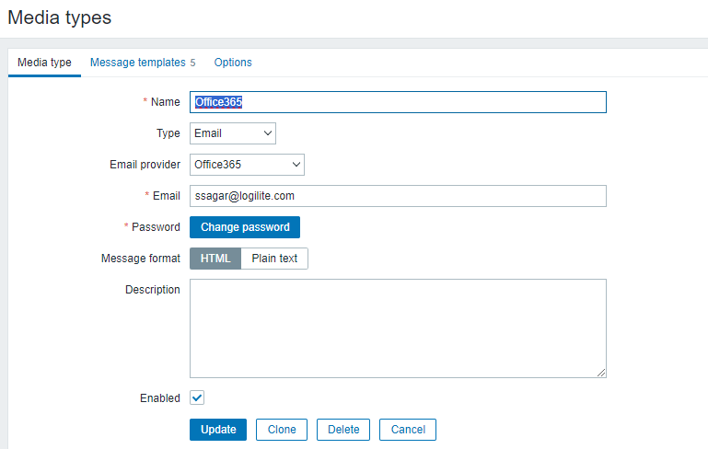

Here, for emai: give email id which will send you and your team emails for alerting.

For password: You need to create an App Password for zabbix from you Microsoft account settings --> Security Info --> Add Method --> App Password --> Give any name --> Get Password --> Now copy and paste that password in Media type.

Edit the User you created and their add Office 365 as your media type and also edit the Action --> Operations --> Send to only --> Office 365.

1. For **HummingBird,**  almost same process, just need to make few edits as below:

A. Create a new item,

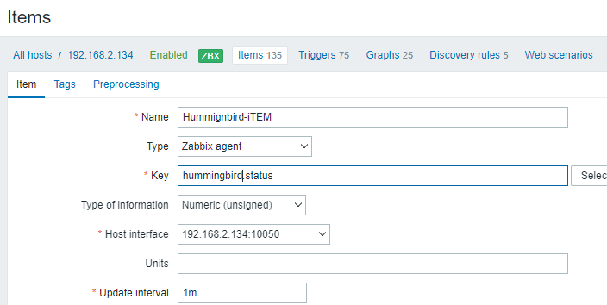

B. Now go to conf file of zabbix-agent2 on your host machine and add another UserParameter as:

UserParameter=hummingbird.status,systemctl is-active --quiet hummingbird; echo $?

C. Now create a trigger:

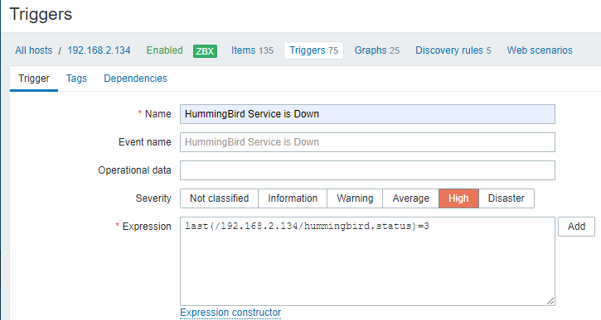

D. After creating trigger, create a new media type for HummingBird --> Go to YellowHammer Media type you created above --> Click on clone --> Give humming media type name --> Change alert_subject = Humming Service is down --> Give ip, host name and webhook link as above for yhserver service.

E. Now add this media type in the user you created

F. Now create a user as:

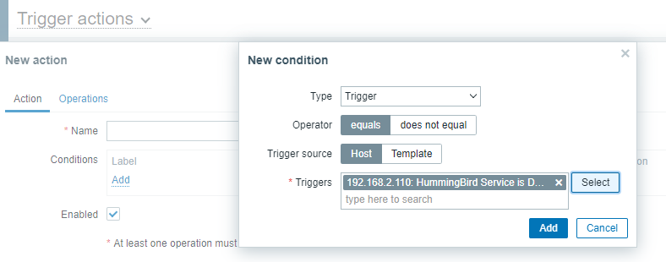Give name to your action: Hummingbird serive is down --> Add condition as above --> Add operation --> Send to user --> select your user --> Send only to --> Hummingbird Media type. Save action.

#####################################################################

1. **For FD Counts**:

UserParameter=fd.count.total,lsof | wc –l

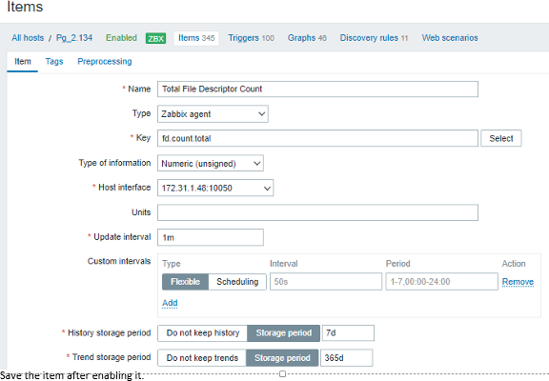  
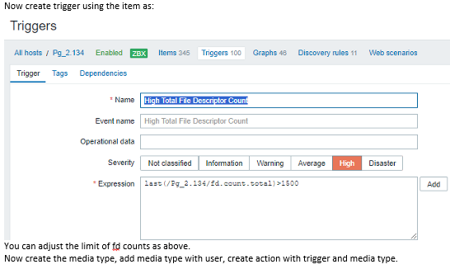

Create new media type by cloning existing media type and edit the information as needed for alert_subject, ip address, hostname and webhook link.

Add this media type in user

Create action using above trigger and media type created for fd counts

1. F**or Thread Counts:**

UserParameter=system.threads.count, ps -eLf | wc –l

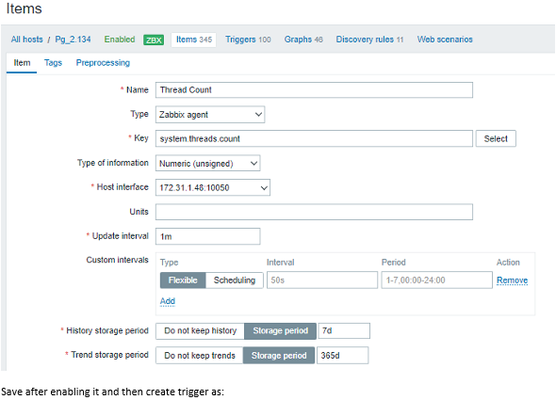  
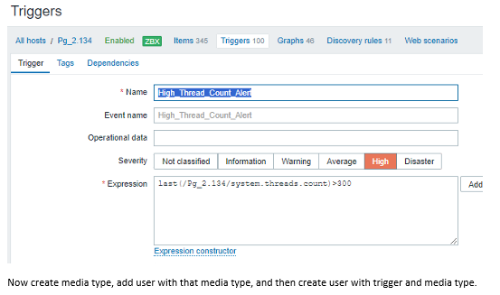

Follow steps as mentioned in FD counts.

########################################################################

1. **High CPU Utilization**: You can use built-in trigger:

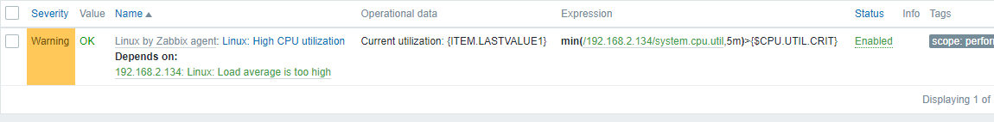

**By default, you can see it will check cpu utilization every 5 mins. You cannot change it.**

Then you can create new trigger like below:

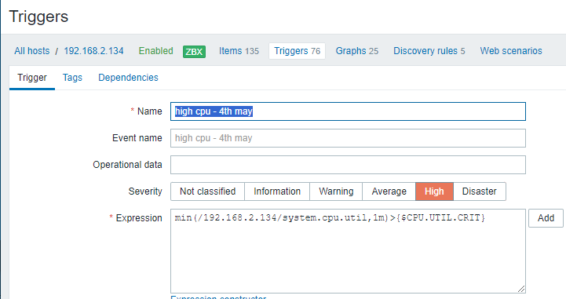

**min(**[/192.168.2.134/system.cpu.util](http://192.168.2.59/zabbix/items.php?form=update&itemid=49730&context=host),1m**)**>{$CPU.UTIL.CRIT}

1. For **High memory:**

**min(**[/192.168.2.134/vm.memory.utilization](http://192.168.2.59/zabbix/items.php?form=update&itemid=49731&context=host),1m**)**>{$MEMORY.UTIL.MAX}

1. For **Postgres service down: Use Built-in trigger as below**



Note: As you can see above, this trigger require postgresql database’s user, its password and connection string. You can assign them them from **DataCollection --> Hosts --> Edit Host --> Macros --> Inherited Macros.**

1. For **MongoDB Service down: Create new trigger as below:**

**nodata(**[/192.168.2.134/mongodb.uptime](http://192.168.2.59/zabbix/items.php?form=update&itemid=50123&context=host),1m**)**=0

